Objective of this assignment:

* To explore the impact of the *function calls* overhead

What you need to do:

1. Implement the greedy **recursive** algorithm to solve the activity-selection problem
2. Implement the greedy **iterative** algorithm to solve the activity-selection problem
3. Repeatedly execute both algorithms on the **same** problem and measure the running time of each algorithm
4. Plot results, compare, analyze and conclude.

**Objective**:

The objective is to study the overhead of the function *calls*. Recursive algorithms call themselves to solve problems. Iterative algorithms do not. Throughout this course (and the textbook), we read that while recursive algorithms may have the same asymptotic running times as iterative homologous algorithms, they are in general less efficient than iterative algorithms (i.e., running time differ by the coefficients of the growth functions). This makes sense because function calls are not free: they take CPU time (just refer to your assembly course of what the cost of the *CALL* and *RET* instructions), left alone the management of the parameters on the stack. This lab aims to check this empirically.

**Programming**

1. Implement RecursiveActivitySelector(k,n), the greedy **recursive** algorithm to solve the activity-selection problem.
2. Implement GreedyActivitySelector(n), the greedy **iterative** algorithm to solve the activity-selection problem.
3. Implement the following program to collect data to plot and analyze. (submit this program with your assignment)

**StudyOverhead(NumberPoints)**

Initialize Array_s[n] // start times

Initialize Array f[n] // finish times

for i = 1 to NumberPoints

TimeRecursive = 0

TimeIterative = 0

for j = 1 to NumberRuns

Initialize set A //Use an array to represent a set A[i] = 0 if $a_{i}∉A$

RecursiveActivitySelector(0, **i-1**)

Collect running time for recursive and add it to TimeRecursive

GreedyActivitySelector(**i-1**)

Collect running time for iterative and add it to TimeIterative

**Collect M[i]** = TimeIterative/TimeRecursive

Dump i and M[i] in a csv file F (submit this file)

**InitializeArrays(n)** // Create about n/2mutually compatible activities

s[0] = 0

f[0] = 0

for i = 1 to n-1

if (i is even)

s[i] = f[i-2]

f[i] = s[i] + 2

else

s[i] = f[i-1] - 1 // s[1] will be negative, but that is fine.

f[i] = f[i-1]+1

**Data collection and analysis**

1) (15 points) On a Tux machine, compile and execute the algorithm *RecursiveActivitySelector* algorithm on the example below. Take a readable screenshot of date, the compilation directives, the execution, the right output.

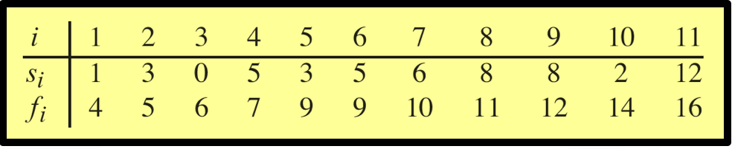

Make sure we see your username and tux machine name as readable as this screenshot template.

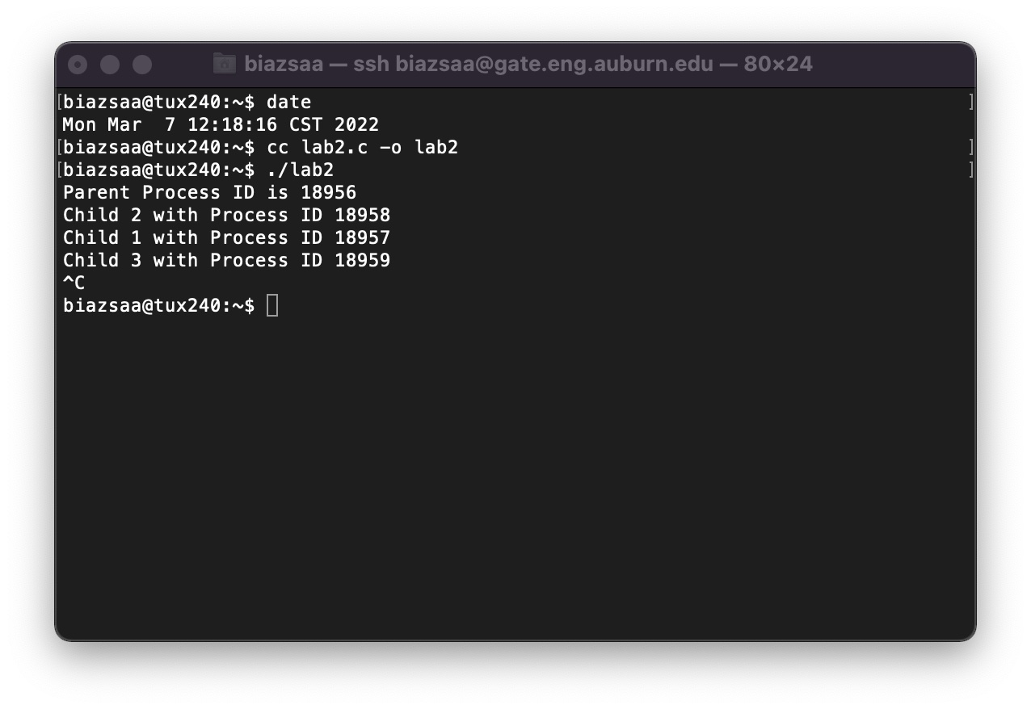

Insert here the screenshot here ...

2) (15 points) On a Tux machine, compile and execute the *GreedyActivitySelector* algorithm on the example below. Take a readable screenshot of date, the compilation directives, the execution, the right output.



Make sure we see your username and tux machine name as readable as this screenshot template.



Insert here the screenshot here ...

2) (30 points) Plot M[i] versus i

(5 points) Submit the csv File f (see pseudocode)

I included with my turn in the csv files and excel file that I used to plot my results.

(25 points) Insert here the plot ...

3) (40 points) Analyze your results and answer the question we asked at the beginning of this programming assignment. Is the iterative algorithm more efficient than the recursive one? You should set the variable NumberPoints and NumberRuns such that they are not too large or too small. If these variables are too large, you will wait too long to collect data (depends on the machine you are using). If the values are too small, you may not see much difference between the two algorithms.

*Compare the two algorithms, discuss and analyze* based on the plot of M[i] versus i. .....

After looking at the plot that was made from the csv files and excel file, it is easier to see that the iterative algorithm is more efficient than the recursive algorithm for the activity-selection problem. This shows an increasing more stabilized ratio as the number of activities increases. This stabilizes around a ratio of 0.6. This indicates that the iterative method is about 40% more efficient on average, primarily due to the absence of recursive call overhead. In this experiment from the java code that was uploaded and ran on the TUX machines, I used NumberPoints = 200 and NumberRuns = 200, which provided a good balance between accuracy and feasibility, ensuring the reliable data without excessive collection time. In real world applications and systems where performance in relation to a large input size are critical, the iterative approach is recommended.

**Report**

* Write a report that will contain, explain, and discuss the plot..
* In addition, your report must contain the following information:
  + whether the program works or not (this must be just ONE sentence)
  + the directions to compile and execute your program
* Good writing is expected.
* Recall that answers must be well written, documented, justified, and presented to get full credit.

**What you need to turn in:**

* Electronic copy of your source program (standalone/separately attached to this assignment)
* Electronic copy of the csv file
* Electronic copy of the report (including your answers) (standalone). Submit the file as a Microsoft Word or PDF file.

**Grading**

Following the provided points distribution.